Good afternoon,

Can you please provide a quote based on the information below. Ready to ship approximately December 26.

Ocean freight and delivery to Amazon warehouses.

**RJ Kids Co**. (Buyer – This is my company)

James Taylor

5862 East 144th Street South

Bixby, Oklahoma 74008

Phone: 918-740-6177

[rjkidsco@gmail.com](mailto:rjkidsco@gmail.com)

**Coaxian Shuanglong Arts & Crafts Plant** (Seller – Factory making items)

Zhuanmiao Industry Zone Coaxian Heze City

Shandong Prov, P.R.C, 274400

Contact: Jessie Zhao

Phone: contact number 18553013318

[sales-3@cxslgy.com](mailto:sales-3@cxslgy.com)

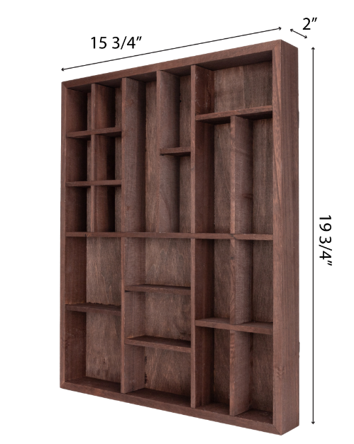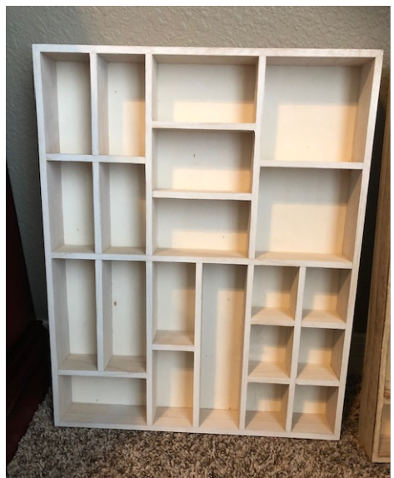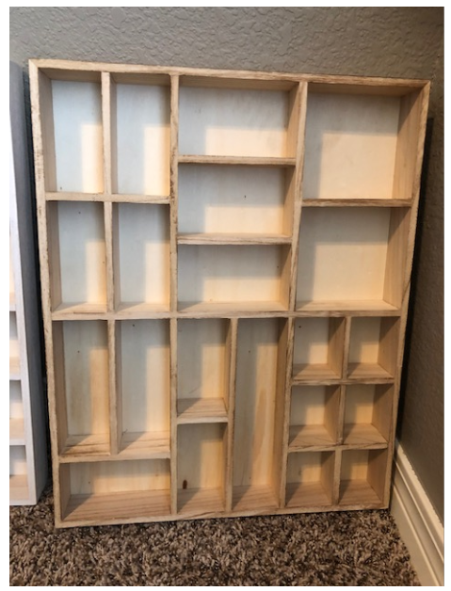

**45RJCO (Burnt)**

**44RJCO (White)**

**42RJCO (Brown)**

**SHIPMENT SUMMARY:**

1. Items are Painted Wooden Display Cases (Three Colors: Brown, White, Tan)
2. Ship to 3 Amazon locations noted below
3. There will be **150 master cartons** (cardboard boxes) which are **53cm x 26cm x 43cm and weight 4Kgs each**

(150 Master Cartons with 4 Pcs per carton)

1. Estimated product ship date December 26, 2020
2. Value is $4000.00 USD

|  |  |  |  |  |
| --- | --- | --- | --- | --- |
| **Shipment ID#** | **Pcs** | **CARTONS** | **Destination** | **Ship to** |
| FBA15TQH5K29 | 160 | 40 | ORD2 | Amazon.com Services, Inc. |
|  |  |  |  | 23714 W Amoco Rd |
|  |  |  |  | CHANNAHON, IL 60410-8758 |
|  |  |  |  | US (ORD2) |
| FBA15TQBKJ78 | 336 | 84 | CLT3 | Amazon.com Services, Inc. |
|  |  |  |  | 6500 Davidson Hwy |
|  |  |  |  | Concord, NC 28027-7995 |
|  |  |  |  | US (CLT3) |
| FBA15TQFR7TB | 104 | 26 | ALB1 | Amazon.com Services, Inc. |
|  |  |  |  | 1835 US Route 9 |
|  |  |  |  | Castleton, NY 12033-9634 |
|  |  |  |  | US (ALB1) |

**SHIPMENT DETAILS:**

|  |  |  |  |  |  |  |
| --- | --- | --- | --- | --- | --- | --- |
| **Shipment ID#** | **SKU** | **FNSKU** | **Pcs** | **CARTONS** | **Destination** | **Ship to** |
| FBA15TQH5K29 |  |  | 160 | 40 | ORD2 | Amazon.com Services, Inc. |
|  | 42RJCO (Brown) | X002I33B3V | 72 | 18 |  | 23714 W Amoco Rd |
|  | 44RJCO (White) | X002PWHCI5 | 44 | 11 |  | CHANNAHON, IL 60410-8758 |
|  | 45RJCO (Burnt) | X002PWHC8F | 44 | 11 |  | US (ORD2) |
|  |  |  |  |  |  |  |
| **Shipment ID#** | **SKU** | **FNSKU** | **Pcs** | **CARTONS** | **Destination** | **Ship to** |
| FBA15TQBKJ78 |  |  | 336 | 84 | CLT3 | Amazon.com Services, Inc. |
|  | 42RJCO (Brown) | X002I33B3V | 104 | 26 |  | 6500 Davidson Hwy |
|  | 44RJCO (White) | X002PWHCI5 | 116 | 29 |  | Concord, NC 28027-7995 |
|  | 45RJCO (Burnt) | X002PWHC8F | 116 | 29 |  | US (CLT3) |
|  |  |  |  |  |  |  |
| **Shipment ID#** | **SKU** | **FNSKU** | **Pcs** | **CARTONS** | **Destination** | **Ship to** |
| FBA15TQFR7TB |  |  | 104 | 26 | ALB1 | Amazon.com Services, Inc. |
|  | 42RJCO (Brown) | X002I33B3V | 24 | 6 |  | 1835 US Route 9 |
|  | 44RJCO (White) | X002PWHCI5 | 40 | 10 |  | Castleton, NY 12033-9634 |
|  | 45RJCO (Burnt) | X002PWHC8F | 40 | 10 |  | US (ALB1) |